Streamlining IT Procurement: Automating Standard Laptop Orders with Flow Designer

Problem Statement:
The current IT procurement process is not very efficient because most of the work is done manually. This is especially noticeable when ordering standard laptops. Even though these laptops usually need to be configured before they are given to users, this step can sometimes be missed or delayed. As a result, users may have to wait longer for their laptops, while the IT team spends extra time handling these tasks manually.

User Story:
As a member of the IT procurement team, I want a simpler and more organized process for ordering standard laptops. Once an order is placed, the required configuration task should be automatically created and assigned to the hardware team. This will help ensure that laptops are configured as soon as they arrive, reduce the waiting time for users, and avoid unnecessary manual work for the IT team.

Project Objective:
The main objective of this project is to use Flow Designer to automate the process of procuring and configuring standard laptops. The automation is designed to make the overall process faster and easier by:
- Making it easier for users to request standard laptops and ensuring they are configured on time.
- Reducing manual work and avoiding common mistakes during the procurement process.
- Assigning tasks to the right IT team members so that resources are used effectively.
- Improving the overall speed, efficiency, and productivity of the IT procurement process.

TASK INITIATION

Milestone 1 : Flow

Activity 1: Create a Flow to Create Catalog task to update the short description after Approval the service Request and it will be Assignment group to Hardware.

- Open ServiceNow.
- Click on All and search for Flow Designer.
- Select Flow Designer under Process Automation.
- In Flow Designer, click New and select Flow.
- In the Flow Properties section, enter the flow name as “Standard Laptop Task”.
- Set the Application to Global.
- Under Run As, select System User.
- Click Submit to create the flow.
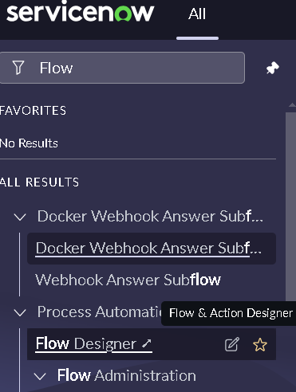
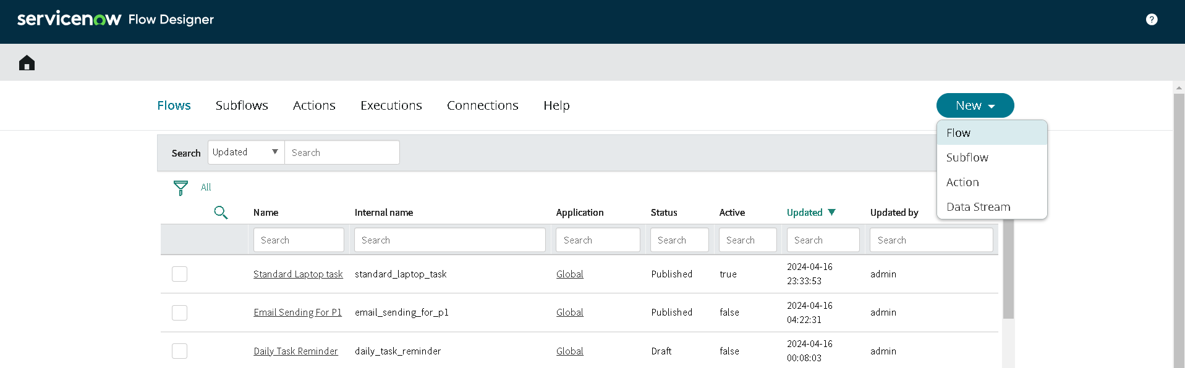

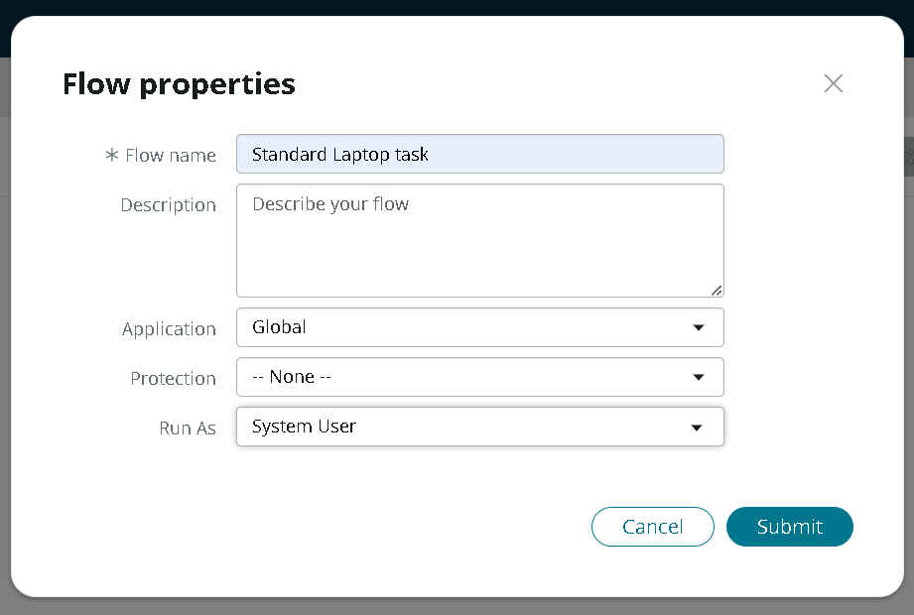

- Click on Add a Trigger.
- In the trigger options, search for “Service Catalog” and select it.
- Click Done to add the trigger.
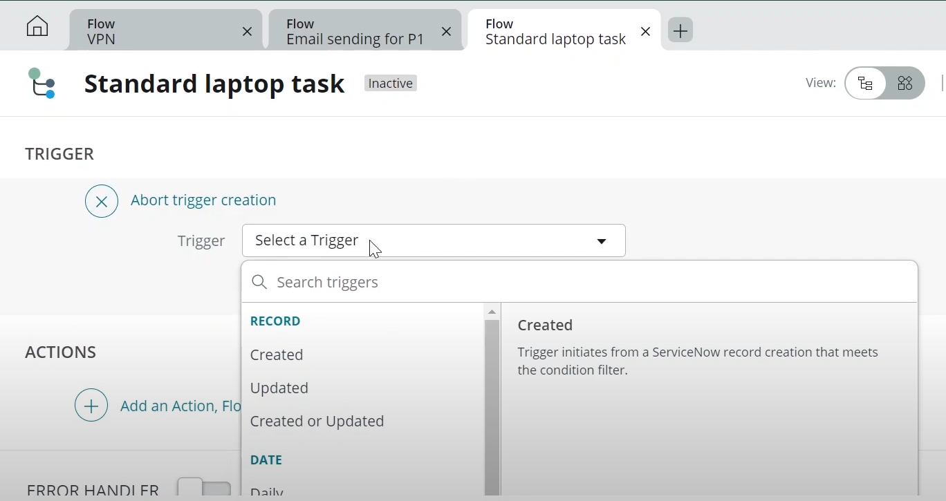
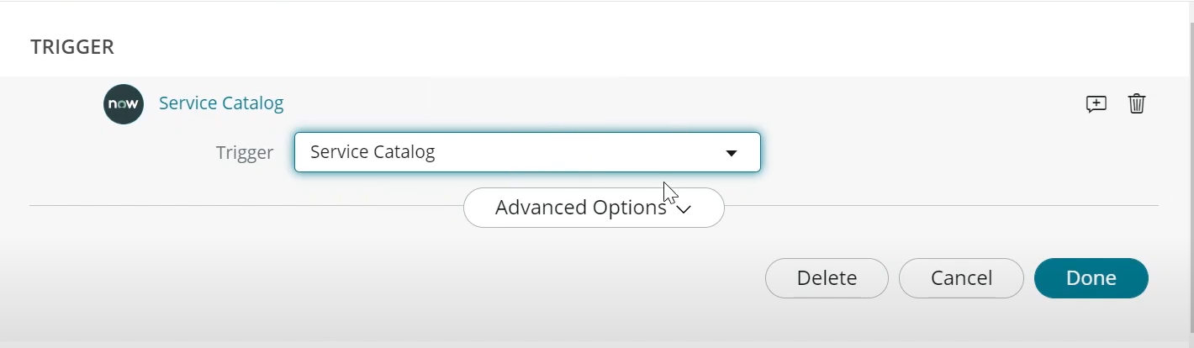

- Under Actions, click on Add an Action.
- In the action options, search for “Create Catalog Task” and select it.
- Enter the required details in the action.
- Make sure the selected Action is Create Catalog Task.
- Drag and drop the Requested Item Record into the Request Item field.
- The Table field will be automatically populated as Catalog Task.
- In the Short Description field, enter “Laptop needs to be configured”.
- Click on Add Field Value.
- Select the Description field and enter “Laptop needs to be configured” as the value.
- Select the Assignment Group field and set the value to Hardware.
- Select the Approval field and set the value to Approved.
- Leave the remaining fields with their default values.
- Click Done to complete the action.
- Click Save to save the flow.
- Click Activate, and then click Activate again to confirm and activate the flow.
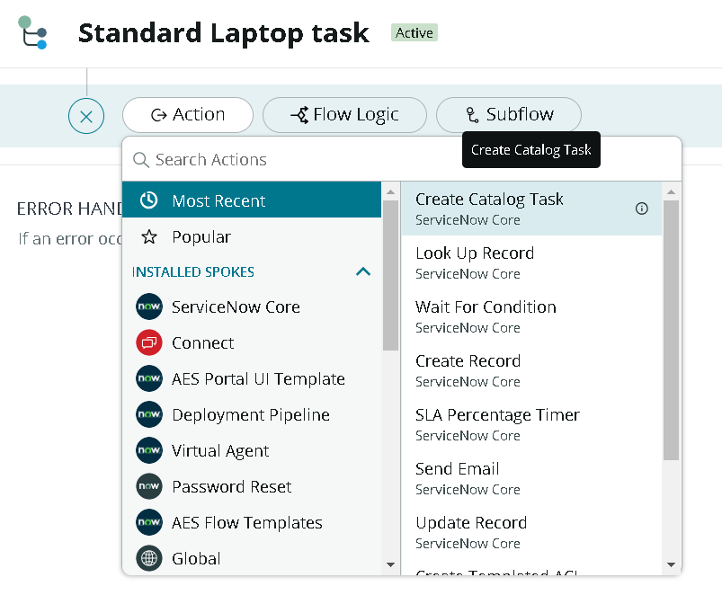
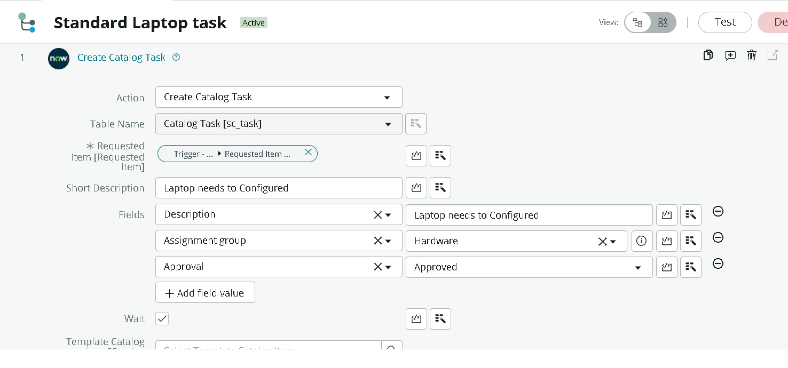

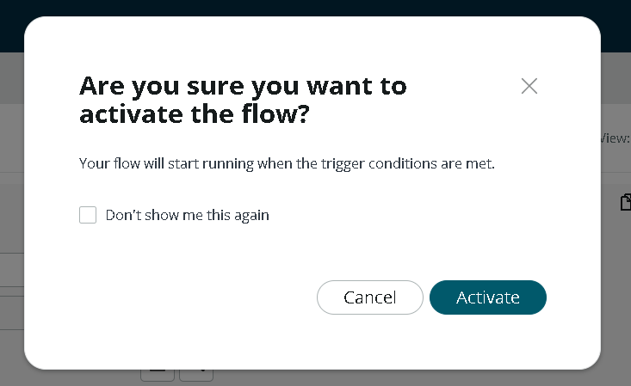

Milestone 2 : Flow assignment

Activity 1 : Flow Assignment to Standard laptop service Catalog.

- Open ServiceNow.
- Click on All and search for Maintain Items.
- Select Maintain Items from the search results.
- In the Name field, search for Standard Laptop and select the corresponding record.
- Open the Standard Laptop record and select Process Engine.
- Remove the existing automations and select Flow.
- Add the flow that was created earlier with the name “Standard Laptop Task”.
- Click on the Menu option and save the record.

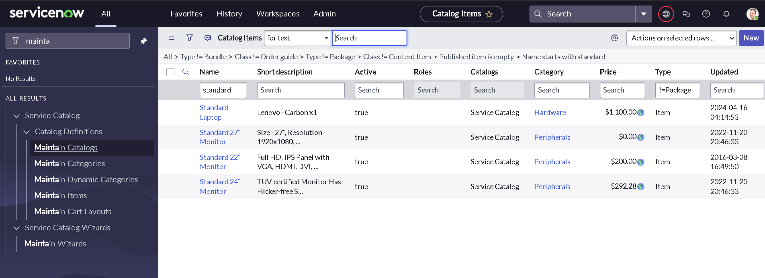

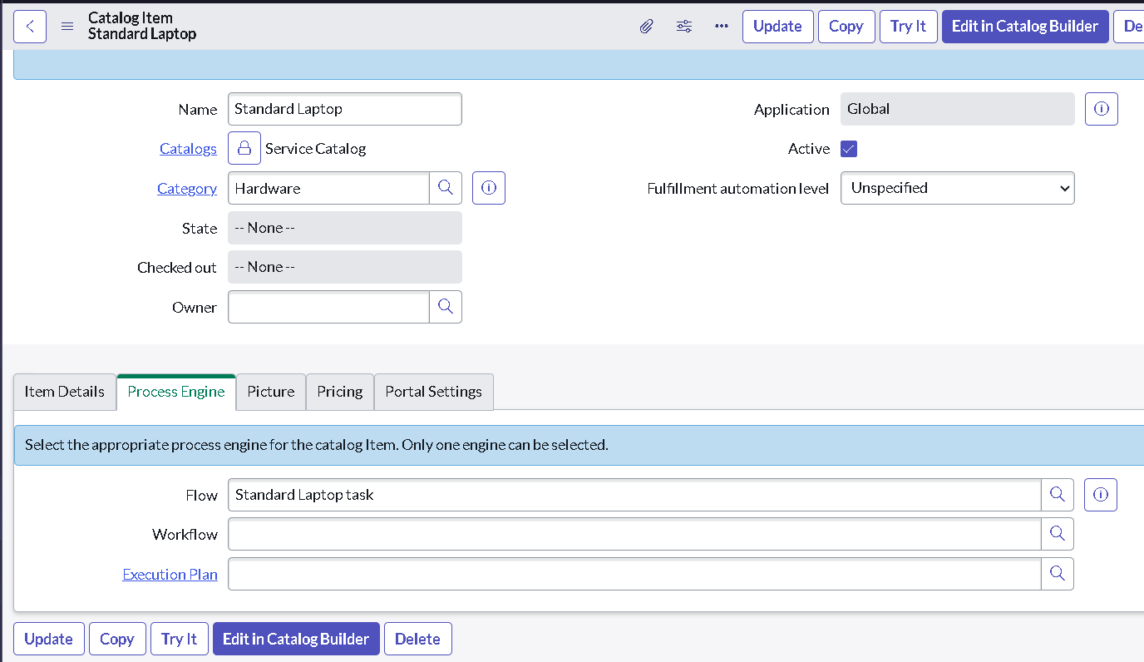

Milestone 3 : Service Catalog

Activity 1: Service Catalog for placing order and get Approval

- Click on All and search for “Service Catalog”.
- Open Service Catalog and select Hardware.
- Scroll down and find “Standard Laptop”, then click on it.
- Click “Order Now” to place the laptop request.
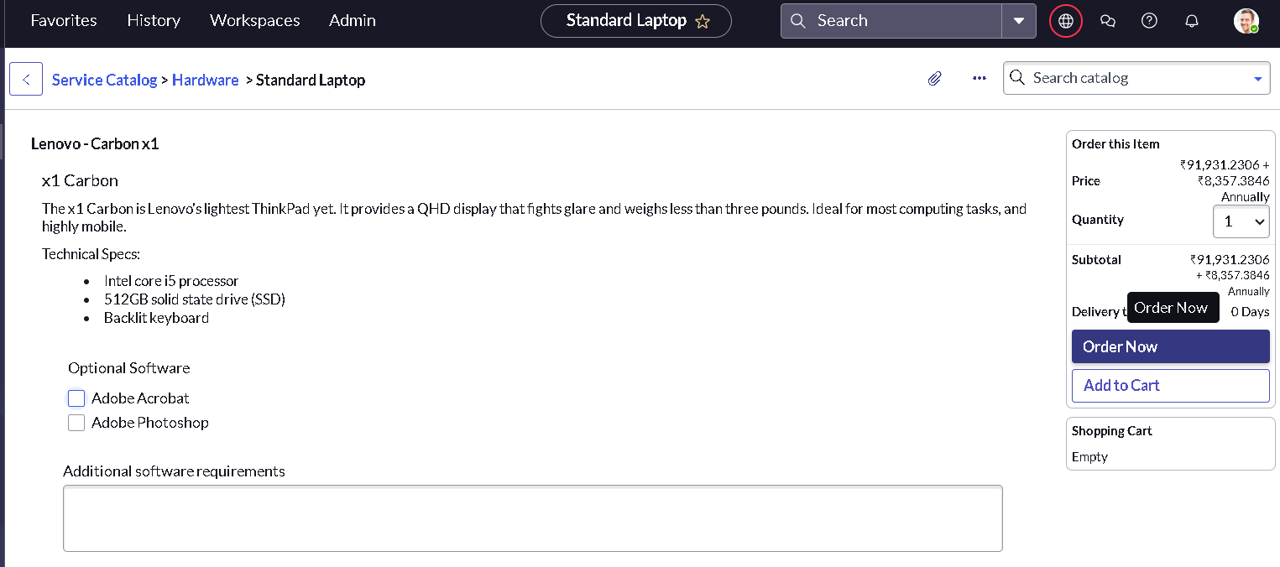
- Now, you can view the Order Status.
- Click on the Request Number to view the details of the request.
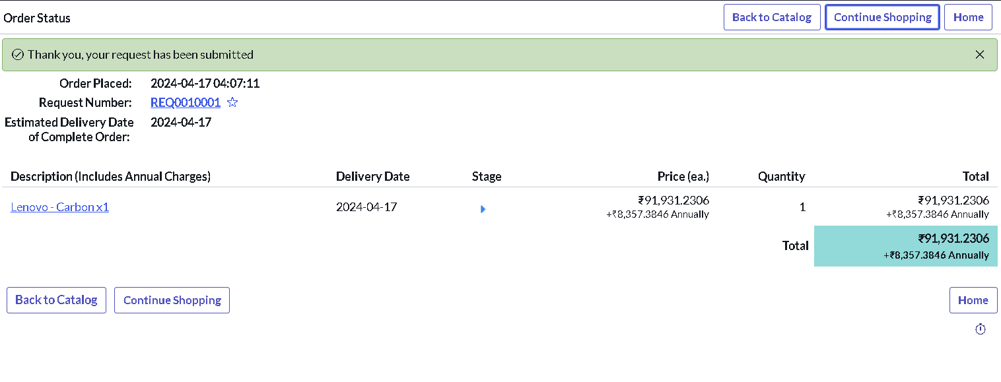
- The Requested Number record will open.
- Scroll down and click on the Approvers section.
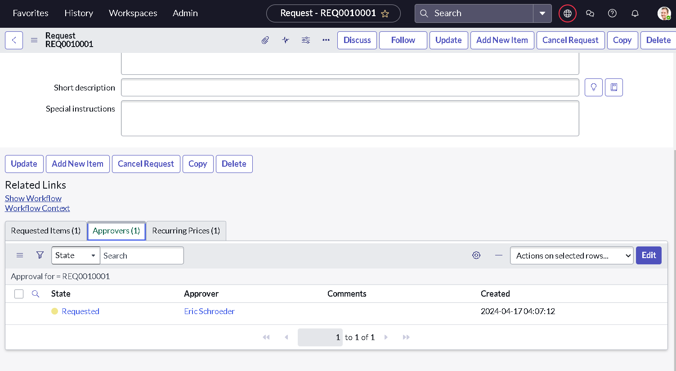
- Right Click on the Record to see config in that Click on the Approve.
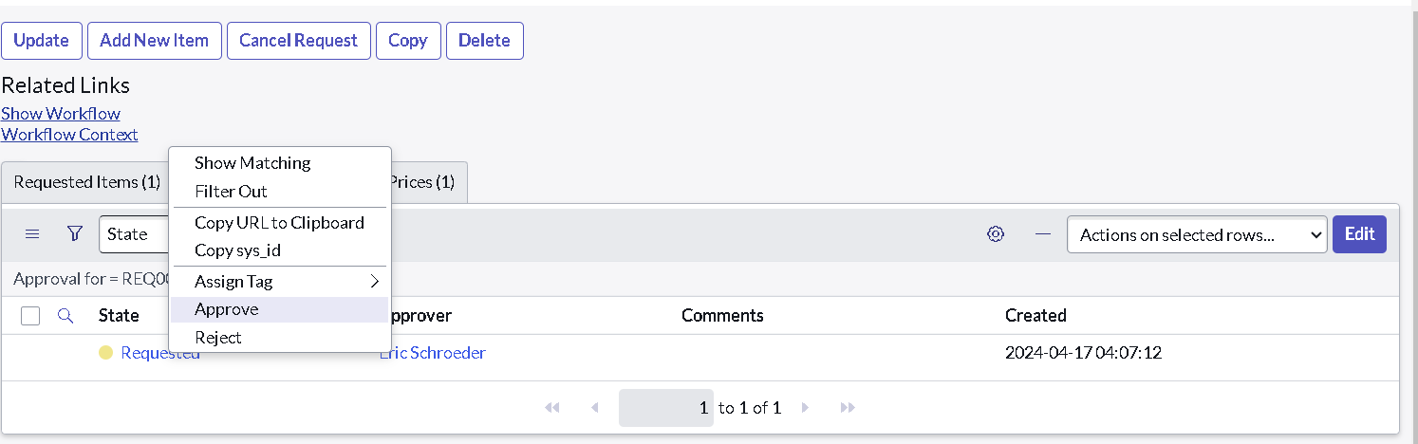
- Click on the Requested Item section.
- Select and open the Requested Item record.
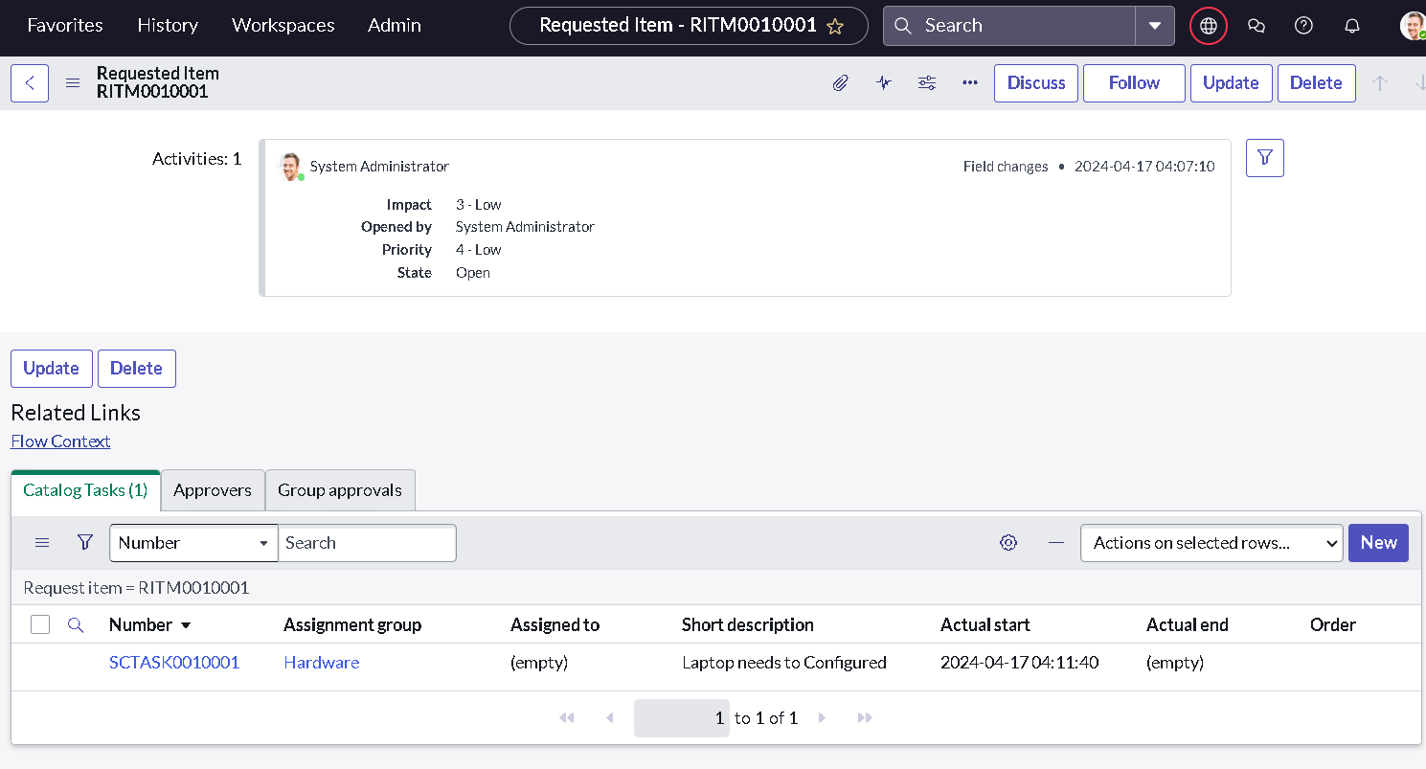
- Scroll down to the Catalog Tasks section.
- Open the record to check the updated status, Short Description, and Assignment Group.
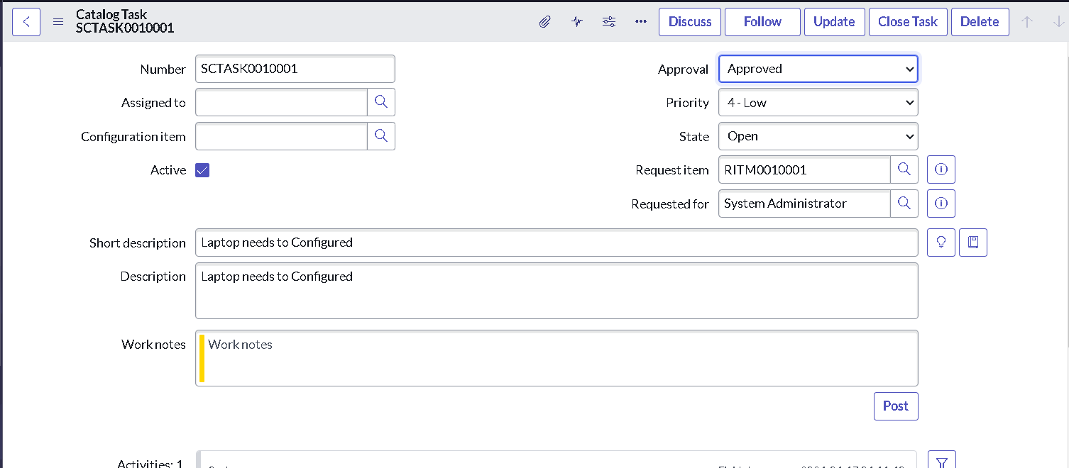

Conclusion :
By automating the standard laptop procurement process using ServiceNow Flow Designer, the project helps reduce manual work and improve the overall process. The automated workflow makes sure that laptops are configured on time, which reduces the waiting time for users. It also helps the IT team manage tasks and resources more efficiently. Overall, this solution makes the procurement process simpler, faster, and more convenient for both users and the IT team.

